**data** epileptic_w;

input ID TRT Age C0 C1 C2 C3 C4;

datalines;

1 0 31 11 5 3 3 3

2 0 30 11 3 5 3 3

………………………..

59 1 37 12 1 4 3 2

;

**run**;

**data** epileptic;

set epileptic_w;

array AC(**1**:**5**) C0-C4;

array Aweek(**1**:**5**) (**0** **2** **4** **6** **8**);

do i=**1** to **5**;

Count = AC[i];

week = Aweek[i];

L_per = log(**2**);

if i eq **1** then L_per=log(**8**);

output;

end;

drop C0-C4 Aweek1 - Aweek5 i;

**run**;

**proc** **print** data=epileptic (obs=**10**);

**run**;

| **Obs** | **ID** | **TRT** | **Age** | **Count** | **week** | **L_per** |
| --- | --- | --- | --- | --- | --- | --- |
| **1** | 1 | 0 | 31 | 11 | 0 | 2.07944 |
| **2** | 1 | 0 | 31 | 5 | 2 | 0.69315 |
| **3** | 1 | 0 | 31 | 3 | 4 | 0.69315 |
| **4** | 1 | 0 | 31 | 3 | 6 | 0.69315 |
| **5** | 1 | 0 | 31 | 3 | 8 | 0.69315 |
| **6** | 2 | 0 | 30 | 11 | 0 | 2.07944 |
| **7** | 2 | 0 | 30 | 3 | 2 | 0.69315 |
| **8** | 2 | 0 | 30 | 5 | 4 | 0.69315 |
| **9** | 2 | 0 | 30 | 3 | 6 | 0.69315 |
| **10** | 2 | 0 | 30 | 3 | 8 | 0.69315 |

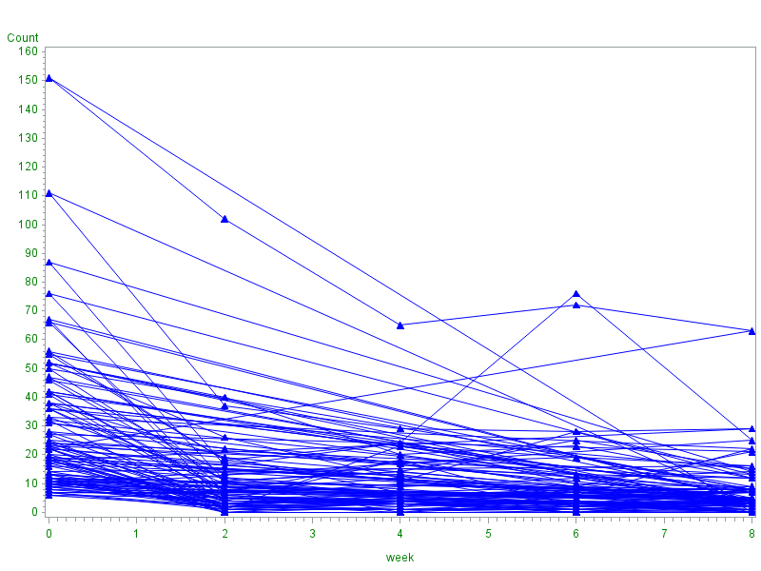

**proc** **glimmix** data=epileptic;

class ID trt (ref='0');

model Count = week trt week*trt/d=poisson link=log offset=L_per solution;

random intercept week/subject=ID type=UN G;

**run**;

**quit**;

| **Model Information** | |
| --- | --- |
| **Data Set** | WORK.EPILEPTIC |
| **Response Variable** | Count |
| **Response Distribution** | Poisson |
| **Link Function** | Log |
| **Variance Function** | Default |
| **Offset Variable** | L_per |
| **Variance Matrix Blocked By** | ID |
| **Estimation Technique** | Residual PL |
| **Degrees of Freedom Method** | Containment |

| **Class Level Information** | | |
| --- | --- | --- |
| **Class** | **Levels** | **Values** |
| **ID** | 59 | 1 2 3 4 5 ……. 59 |
| **TRT** | 2 | 1 0 |

|  |  |
| --- | --- |
| **Number of Observations Read** | 295 |
| **Number of Observations Used** | 295 |

| **Dimensions** | |
| --- | --- |
| **G-side Cov. Parameters** | 3 |
| **Columns in X** | 6 |
| **Columns in Z per Subject** | 2 |
| **Subjects (Blocks in V)** | 59 |
| **Max Obs per Subject** | 5 |

| **Optimization Information** | |
| --- | --- |
| **Optimization Technique** | Dual Quasi-Newton |
| **Parameters in Optimization** | 3 |
| **Lower Boundaries** | 2 |
| **Upper Boundaries** | 0 |
| **Fixed Effects** | Profiled |
| **Starting From** | Data |

| **Iteration History** | | | | | |
| --- | --- | --- | --- | --- | --- |
| **Iteration** | **Restarts** | **Subiterations** | **Objective Function** | **Change** | **Max Gradient** |
| **0** | **0** | **5** | 715.90199832 | 2.00000000 | 0.141681 |
| **1** | **0** | **6** | 790.0318566 | 0.25874549 | 0.00005 |
| **2** | **0** | **5** | 799.18843282 | 0.00762797 | 0.000969 |
| **18** | **0** | **1** | 799.46552535 | 0.00000026 | 0.000155 |
| **19** | **0** | **1** | 799.46552774 | 0.00000463 | 0.001866 |

|  |
| --- |
| Did not converge. |

**proc** **glimmix** data=epileptic method=quad(QPOINTS=**5**);

class ID trt (ref='0');

model Count = week trt week*trt/d=poisson link=log offset=L_per solution;

random intercept week/subject=ID type=UN G;

**run**;

**quit**;

| **Model Information** | |
| --- | --- |
| **Data Set** | WORK.EPILEPTIC |
| **Response Variable** | Count |
| **Response Distribution** | Poisson |
| **Link Function** | Log |
| **Variance Function** | Default |
| **Offset Variable** | L_per |
| **Variance Matrix Blocked By** | ID |
| **Estimation Technique** | Maximum Likelihood |
| **Likelihood Approximation** | Gauss-Hermite Quadrature |
| **Degrees of Freedom Method** | Containment |

| **Class Level Information** | | |
| --- | --- | --- |
| **Class** | **Levels** | **Values** |
| **ID** | 59 | 1 2 3 4 5 6 7 8 9 10 11 12 13 14 15 16 17 18 19 20 21 22 23 24 25 26 27 28 29 30 31 32 33 34 35 36 37 38 39 40 41 42 43 44 45 46 47 48 49 50 51 52 53 54 55 56 57 58 59 |
| **TRT** | 2 | 1 0 |

|  |  |
| --- | --- |
| **Number of Observations Read** | 295 |
| **Number of Observations Used** | 295 |

| **Dimensions** | |
| --- | --- |
| **G-side Cov. Parameters** | 3 |
| **Columns in X** | 6 |
| **Columns in Z per Subject** | 2 |
| **Subjects (Blocks in V)** | 59 |
| **Max Obs per Subject** | 5 |

| **Optimization Information** | |
| --- | --- |
| **Optimization Technique** | Dual Quasi-Newton |
| **Parameters in Optimization** | 7 |
| **Lower Boundaries** | 2 |
| **Upper Boundaries** | 0 |
| **Fixed Effects** | Not Profiled |
| **Starting From** | GLM estimates |
| **Quadrature Points** | 5 |

| **Iteration History** | | | | | |
| --- | --- | --- | --- | --- | --- |
| **Iteration** | **Restarts** | **Evaluations** | **Objective Function** | **Change** | **Max Gradient** |
| **0** | **0** | 4 | 1935.877681 | . | 1360.217 |
| **1** | **0** | 5 | 1934.0660428 | 1.81163821 | 1278.973 |
| **2** | **0** | 5 | 1931.4844275 | 2.58161522 | 1243.717 |
| **3** | **0** | 5 | 1929.8241138 | 1.66031377 | 1179.902 |
| **4** | **0** | 5 | 1920.0003502 | 9.82376352 | 491.0731 |
| **5** | **0** | 3 | 1913.8175124 | 6.18283779 | 1285.27 |
| **6** | **0** | 3 | 1912.8773189 | 0.94019352 | 674.922 |
| **7** | **0** | 4 | 1910.8501449 | 2.02717403 | 497.4587 |
| **8** | **0** | 5 | 1910.4180459 | 0.43209903 | 192.8727 |
| **9** | **0** | 2 | 1909.983809 | 0.43423687 | 54.65148 |
| **10** | **0** | 3 | 1909.915481 | 0.06832802 | 45.72635 |
| **11** | **0** | 3 | 1909.8969513 | 0.01852967 | 26.35039 |
| **12** | **0** | 3 | 1909.8935545 | 0.00339679 | 4.640038 |
| **13** | **0** | 3 | 1909.8931368 | 0.00041772 | 6.534372 |
| **14** | **0** | 3 | 1909.8930695 | 0.00006733 | 0.209633 |
| **15** | **0** | 3 | 1909.8930693 | 0.00000021 | 0.00327 |

|  |
| --- |
| Convergence criterion (GCONV=1E-8) satisfied. |

| **Fit Statistics** | |
| --- | --- |
| **-2 Log Likelihood** | 1909.89 |
| **AIC (smaller is better)** | 1923.89 |
| **AICC (smaller is better)** | 1924.28 |
| **BIC (smaller is better)** | 1938.44 |
| **CAIC (smaller is better)** | 1945.44 |
| **HQIC (smaller is better)** | 1929.57 |

| **Fit Statistics for Conditional Distribution** | |
| --- | --- |
| **-2 log L(Count | r. effects)** | 1562.24 |
| **Pearson Chi-Square** | 472.31 |
| **Pearson Chi-Square / DF** | 1.60 |

| **Estimated G Matrix** | | | |
| --- | --- | --- | --- |
| **Effect** | **Row** | **Col1** | **Col2** |
| Intercept | **1** | 0.5277 | 0.01120 |
| week | **2** | 0.01120 | 0.005059 |

| **Covariance Parameter Estimates** | | | |
| --- | --- | --- | --- |
| **Cov Parm** | **Subject** | **Estimate** | **Standard Error** |
| **UN(1,1)** | ID | 0.5277 | 0.1045 |
| **UN(2,1)** | ID | 0.01120 | 0.008762 |
| **UN(2,2)** | ID | 0.005059 | 0.001461 |

| **Solutions for Fixed Effects** | | | | | | |
| --- | --- | --- | --- | --- | --- | --- |
| **Effect** | **TRT** | **Estimate** | **Standard Error** | **DF** | **t Value** | **Pr > |t|** |
| **Intercept** |  | 1.1039 | 0.1428 | 57 | 7.73 | <.0001 |
| **week** |  | -0.01133 | 0.01692 | 57 | -0.67 | 0.5057 |
| **TRT** | 1 | 0.01755 | 0.1966 | 177 | 0.09 | 0.9290 |
| **TRT** | 0 | 0 | . | . | . | . |
| **week*TRT** | 1 | -0.04675 | 0.02350 | 177 | -1.99 | 0.0482 |
| **week*TRT** | 0 | 0 | . | . | . | . |

| **Type III Tests of Fixed Effects** | | | | |
| --- | --- | --- | --- | --- |
| **Effect** | **Num DF** | **Den DF** | **F Value** | **Pr > F** |
| **week** | 1 | 57 | 8.09 | 0.0062 |
| **TRT** | 1 | 177 | 0.01 | 0.9290 |
| **week*TRT** | 1 | 177 | 3.96 | 0.0482 |

**proc** **glimmix** data=epileptic method=quad(QPOINTS=**20**);

class ID trt (ref='0');

model Count = week trt week*trt/d=poisson link=log offset=L_per solution;

random intercept week/subject=ID type=UN G;

**run**;

**quit**;

| **Solutions for Fixed Effects** | | | | | | |
| --- | --- | --- | --- | --- | --- | --- |
| **Effect** | **TRT** | **Estimate** | **Standard Error** | **DF** | **t Value** | **Pr > |t|** |
| **Intercept** |  | 1.1039 | 0.1428 | 57 | 7.73 | <.0001 |
| **week** |  | -0.01133 | 0.01692 | 57 | -0.67 | 0.5058 |
| **TRT** | 1 | 0.01755 | 0.1966 | 177 | 0.09 | 0.9290 |
| **TRT** | 0 | 0 | . | . | . | . |
| **week*TRT** | 1 | -0.04675 | 0.02351 | 177 | -1.99 | 0.0482 |
| **week*TRT** | 0 | 0 | . | . | . | . |

**proc** **glimmix** data=epileptic method=quad(QPOINTS=**50**);

class ID trt (ref='0');

model Count = week trt week*trt/d=poisson link=log offset=L_per solution;

random intercept week/subject=ID type=UN G;

**run**;

**quit**;

| **Solutions for Fixed Effects** | | | | | | |
| --- | --- | --- | --- | --- | --- | --- |
| **Effect** | **TRT** | **Estimate** | **Standard Error** | **DF** | **t Value** | **Pr > |t|** |
| **Intercept** |  | 1.1039 | 0.1428 | 57 | 7.73 | <.0001 |
| **week** |  | -0.01133 | 0.01692 | 57 | -0.67 | 0.5058 |
| **TRT** | 1 | 0.01755 | 0.1966 | 177 | 0.09 | 0.9290 |
| **TRT** | 0 | 0 | . | . | . | . |
| **week*TRT** | 1 | -0.04675 | 0.02351 | 177 | -1.99 | 0.0482 |
| **week*TRT** | 0 | 0 | . | . | . | . |

**The negative binomial model is an alternative to the Poisson model. The interpretation is similar, and it allow for overdispersion. In the negative binomial model** var(Y)=μ+kμ2

**proc** **glimmix** data=epileptic method=quad(QPOINTS=**20**);

class ID trt (ref='0');

model Count = week trt week*trt/d=negbin link=log offset=L_per solution;

random intercept week/subject=ID type=UN G;

**run**;

**quit**;

|  |
| --- |
| The SAS System |

The GLIMMIX Procedure

| **Model Information** | |
| --- | --- |
| **Data Set** | WORK.EPILEPTIC |
| **Response Variable** | Count |
| **Response Distribution** | Negative Binomial |
| **Link Function** | Log |
| **Variance Function** | Default |
| **Offset Variable** | L_per |
| **Variance Matrix Blocked By** | ID |
| **Estimation Technique** | Maximum Likelihood |
| **Likelihood Approximation** | Gauss-Hermite Quadrature |
| **Degrees of Freedom Method** | Containment |

| **Class Level Information** | | |
| --- | --- | --- |
| **Class** | **Levels** | **Values** |
| **ID** | 59 | 1 2 3 4 5 6 7 8 9 10 11 12 13 14 15 16 17 18 19 20 21 22 23 24 25 26 27 28 29 30 31 32 33 34 35 36 37 38 39 40 41 42 43 44 45 46 47 48 49 50 51 52 53 54 55 56 57 58 59 |
| **TRT** | 2 | 1 0 |

|  |  |
| --- | --- |
| **Number of Observations Read** | 295 |
| **Number of Observations Used** | 295 |

| **Dimensions** | |
| --- | --- |
| **G-side Cov. Parameters** | 3 |
| **R-side Cov. Parameters** | 1 |
| **Columns in X** | 6 |
| **Columns in Z per Subject** | 2 |
| **Subjects (Blocks in V)** | 59 |
| **Max Obs per Subject** | 5 |

| **Optimization Information** | |
| --- | --- |
| **Optimization Technique** | Dual Quasi-Newton |
| **Parameters in Optimization** | 8 |
| **Lower Boundaries** | 3 |
| **Upper Boundaries** | 0 |
| **Fixed Effects** | Not Profiled |
| **Starting From** | GLM estimates |
| **Quadrature Points** | 20 |

| **Iteration History** | | | | | |
| --- | --- | --- | --- | --- | --- |
| **Iteration** | **Restarts** | **Evaluations** | **Objective Function** | **Change** | **Max Gradient** |
| **0** | **0** | 4 | 1864.9791757 | . | 1322.935 |
| **1** | **0** | 5 | 1863.4623877 | 1.51678805 | 1357.649 |
| **61** | **0** | 3 | 1773.992202 | 0.00000511 | 1021.949 |

|  |
| --- |
| Convergence criterion (GCONV=1E-8) satisfied. |

| **Fit Statistics** | |
| --- | --- |
| **-2 Log Likelihood** | 1773.99 |
| **AIC (smaller is better)** | 1789.99 |
| **AICC (smaller is better)** | 1790.50 |
| **BIC (smaller is better)** | 1806.61 |
| **CAIC (smaller is better)** | 1814.61 |
| **HQIC (smaller is better)** | 1796.48 |

| **Fit Statistics for Conditional Distribution** | |
| --- | --- |
| **-2 log L(Count | r. effects)** | 1570.51 |
| **Pearson Chi-Square** | 227.57 |
| **Pearson Chi-Square / DF** | 0.77 |

| **Estimated G Matrix** | | | |
| --- | --- | --- | --- |
| **Effect** | **Row** | **Col1** | **Col2** |
| **Intercept** | **1** | 0.5610 | 0.04230 |
| **week** | **2** | 0.04230 | 0.003190 |

| **Covariance Parameter Estimates** | | | |
| --- | --- | --- | --- |
| **Cov Parm** | **Subject** | **Estimate** | **Standard Error** |
| **UN(1,1)** | **ID** | 0.5610 | 0.1585 |
| **UN(2,1)** | **ID** | 0.04230 | 0.01823 |
| **UN(2,2)** | **ID** | 0.003190 | 0.003409 |
| **Scale** |  | **0.1407** | **0.02871** |

| **Solutions for Fixed Effects** | | | | | | |
| --- | --- | --- | --- | --- | --- | --- |
| **Effect** | **TRT** | **Estimate** | **Standard Error** | **DF** | **t Value** | **Pr > |t|** |
| **Intercept** |  | 1.1728 | 0.1586 | 57 | 7.40 | <.0001 |
| **week** |  | -0.02103 | 0.01921 | 57 | -1.09 | 0.2782 |
| **TRT** | **1** | -0.01187 | 0.2179 | 177 | -0.05 | 0.9566 |
| **TRT** | **0** | 0 | . | . | . | . |
| **week*TRT** | **1** | -0.04466 | 0.02665 | 177 | -1.68 | 0.0955 |
| **week*TRT** | **0** | 0 | . | . | . | . |

| **Type III Tests of Fixed Effects** | | | | |
| --- | --- | --- | --- | --- |
| **Effect** | **Num DF** | **Den DF** | **F Value** | **Pr > F** |
| **week** | 1 | 57 | 9.50 | 0.0032 |
| **TRT** | 1 | 177 | 0.00 | 0.9566 |
| **week*TRT** | 1 | 177 | 2.81 | 0.0955 |

**Now we’ll go back to the obesity example from a few classes ago.**

**proc** **glimmix** data=obesity4;

class ID gender;

model OB = gender age age*age/d=bin link=logit solution;

random intercept/subject=ID G;

**run**;

**quit**;

| **Solutions for Fixed Effects** | | | | | | |
| --- | --- | --- | --- | --- | --- | --- |
| **Effect** | **Gender** | **Estimate** | **Standard Error** | **DF** | **t Value** | **Pr > |t|** |
| **Intercept** |  | -4.7692 | 0.6546 | 1768 | -7.29 | <.0001 |
| **Gender** | 0 | 0.007958 | 0.1122 | 3538 | 0.07 | 0.9435 |
| **Gender** | 1 | 0 | . | . | . | . |
| **age** |  | 0.5057 | 0.1085 | 3538 | 4.66 | <.0001 |
| **age*age** |  | -0.01953 | 0.004404 | 3538 | -4.44 | <.0001 |

**Now let’s change the estimation method.**

**proc** **glimmix** data=obesity4 method=quad(QPOINTS=**20**);

class ID gender;

model OB = gender age age*age/d=bin link=logit solution;

random intercept/subject=ID G;

**run**;

**quit**;

| **Model Information** | |
| --- | --- |
| **Data Set** | WORK.OBESITY4 |
| **Response Variable** | OB |
| **Response Distribution** | Binomial |
| **Link Function** | Logit |
| **Variance Function** | Default |
| **Variance Matrix Blocked By** | ID |
| **Estimation Technique** | Maximum Likelihood |
| **Likelihood Approximation** | Gauss-Hermite Quadrature |
| **Degrees of Freedom Method** | Containment |

|  |  |
| --- | --- |
| **Number of Observations Read** | 5310 |
| **Number of Observations Used** | 5310 |

| **Dimensions** | |
| --- | --- |
| **G-side Cov. Parameters** | 1 |
| **Columns in X** | 5 |
| **Columns in Z per Subject** | 1 |
| **Subjects (Blocks in V)** | 1770 |
| **Max Obs per Subject** | 3 |

| **Optimization Information** | |
| --- | --- |
| **Optimization Technique** | Dual Quasi-Newton |
| **Parameters in Optimization** | 5 |
| **Lower Boundaries** | 1 |
| **Upper Boundaries** | 0 |
| **Fixed Effects** | Not Profiled |
| **Starting From** | GLM estimates |
| **Quadrature Points** | 20 |

| **Iteration History** | | | | | |
| --- | --- | --- | --- | --- | --- |
| **Iteration** | **Restarts** | **Evaluations** | **Objective Function** | **Change** | **Max Gradient** |
| **0** | **0** | 4 | 4554.6367741 | . | 59955.15 |
| **1** | **0** | 11 | 4418.8644106 | 135.77236355 | 2520.897 |
| **2** | **0** | 3 | 4372.1095284 | 46.75488217 | 2407.38 |
| **13** | **0** | 3 | 4260.2033793 | 0.00000318 | 0.948232 |

|  |
| --- |
| Convergence criterion (GCONV=1E-8) satisfied. |

| **Fit Statistics** | |
| --- | --- |
| **-2 Log Likelihood** | 4260.20 |
| **AIC (smaller is better)** | 4270.20 |
| **AICC (smaller is better)** | 4270.21 |
| **BIC (smaller is better)** | 4297.60 |
| **CAIC (smaller is better)** | 4302.60 |
| **HQIC (smaller is better)** | 4280.32 |

| **Fit Statistics for Conditional Distribution** | |
| --- | --- |
| **-2 log L(OB | r. effects)** | 1777.74 |
| **Pearson Chi-Square** | 1371.44 |
| **Pearson Chi-Square / DF** | 0.26 |

| **Estimated G Matrix** | | |
| --- | --- | --- |
| **Effect** | **Row** | **Col1** |
| Intercept | **1** | 12.1519 |

| **Covariance Parameter Estimates** | | | |
| --- | --- | --- | --- |
| **Cov Parm** | **Subject** | **Estimate** | **Standard Error** |
| **Intercept** | ID | 12.1519 | 1.2655 |

| **Solutions for Fixed Effects** | | | | | | |
| --- | --- | --- | --- | --- | --- | --- |
| **Effect** | **Gender** | **Estimate** | **Standard Error** | **DF** | **t Value** | **Pr > |t|** |
| **Intercept** |  | -8.8173 | 0.9715 | 1768 | -9.08 | <.0001 |
| **Gender** | 0 | 0.01192 | 0.2208 | 3538 | 0.05 | 0.9569 |
| **Gender** | 1 | 0 | . | . | . | . |
| **age** |  | 0.8943 | 0.1535 | 3538 | 5.83 | <.0001 |
| **age*age** |  | -0.03414 | 0.006203 | 3538 | -5.50 | <.0001 |

| **Type III Tests of Fixed Effects** | | | | |
| --- | --- | --- | --- | --- |
| **Effect** | **Num DF** | **Den DF** | **F Value** | **Pr > F** |
| **Gender** | 1 | 3538 | 0.00 | 0.9569 |
| **age** | 1 | 3538 | 33.96 | <.0001 |
| **age*age** | 1 | 3538 | 30.30 | <.0001 |

**proc** **glimmix** data=obesity4 method=quad(QPOINTS=**20**);

class ID gender;

model OB = gender Cohort age age*age Cohort*age Cohort*age*age/d=bin link=logit solution;

random intercept/subject=ID G;

**run**;

**quit**;

| **Optimization Information** | |
| --- | --- |
| **Optimization Technique** | Dual Quasi-Newton |
| **Parameters in Optimization** | 8 |
| **Lower Boundaries** | 1 |
| **Upper Boundaries** | 0 |
| **Fixed Effects** | Not Profiled |
| **Starting From** | GLM estimates |
| **Quadrature Points** | 20 |

| **Iteration History** | | | | | |
| --- | --- | --- | --- | --- | --- |
| **Iteration** | **Restarts** | **Evaluations** | **Objective Function** | **Change** | **Max Gradient** |
| **0** | **0** | 4 | 4546.4496857 | . | 614464.1 |
| **1** | **0** | 18 | 4426.7463567 | 119.70332902 | 21675.7 |
| **20** | **0** | 3 | 4251.5463724 | 0.00000025 | 0.689749 |

|  |
| --- |
| Convergence criterion (GCONV=1E-8) satisfied. |

| **Fit Statistics** | |
| --- | --- |
| **-2 Log Likelihood** | 4251.55 |
| **AIC (smaller is better)** | 4267.55 |
| **AICC (smaller is better)** | 4267.57 |
| **BIC (smaller is better)** | 4311.38 |
| **CAIC (smaller is better)** | 4319.38 |
| **HQIC (smaller is better)** | 4283.74 |

| **Fit Statistics for Conditional Distribution** | |
| --- | --- |
| **-2 log L(OB | r. effects)** | 1766.86 |
| **Pearson Chi-Square** | 1364.87 |
| **Pearson Chi-Square / DF** | 0.26 |

| **Estimated G Matrix** | | |
| --- | --- | --- |
| **Effect** | **Row** | **Col1** |
| Intercept | **1** | 12.2248 |

| **Covariance Parameter Estimates** | | | |
| --- | --- | --- | --- |
| **Cov Parm** | **Subject** | **Estimate** | **Standard Error** |
| **Intercept** | ID | 12.2248 | 1.2871 |

| **Solutions for Fixed Effects** | | | | | | |
| --- | --- | --- | --- | --- | --- | --- |
| **Effect** | **Gender** | **Estimate** | **Standard Error** | **DF** | **t Value** | **Pr > |t|** |
| **Intercept** |  | -16.8308 | 3.5234 | 1768 | -4.78 | <.0001 |
| **Gender** | 0 | 0.01383 | 0.2214 | 3535 | 0.06 | 0.9502 |
| **Gender** | 1 | 0 | . | . | . | . |
| **Cohort** |  | 0.8252 | 0.5254 | 3535 | 1.57 | 0.1163 |
| **age** |  | 2.4963 | 0.6063 | 3535 | 4.12 | <.0001 |
| **age*age** |  | -0.1082 | 0.03052 | 3535 | -3.54 | 0.0004 |
| **Cohort*age** |  | -0.1599 | 0.06970 | 3535 | -2.29 | 0.0219 |
| **Cohort*age*age** |  | 0.007157 | 0.002611 | 3535 | 2.74 | 0.0062 |

| **Type III Tests of Fixed Effects** | | | | |
| --- | --- | --- | --- | --- |
| **Effect** | **Num DF** | **Den DF** | **F Value** | **Pr > F** |
| **Gender** | 1 | 3535 | 0.00 | 0.9502 |
| **Cohort** | 1 | 3535 | 2.47 | 0.1163 |
| **age** | 1 | 3535 | 16.95 | <.0001 |
| **age*age** | 1 | 3535 | 12.56 | 0.0004 |
| **Cohort*age** | 1 | 3535 | 5.26 | 0.0219 |
| **Cohort*age*age** | 1 | 3535 | 7.51 | 0.0062 |

**proc** **glimmix** data=obesity4 OR method=quad(QPOINTS=**20**);

class ID gender;

model OB = Cohort age age*age Cohort*age Cohort*age*age/d=bin link=logit solution;

random intercept/subject=ID G;

output out=full_mod pred(NOBLUP ILINK)=pred pred(ILINK)=pred2;

run;

**quit**;

| **Optimization Information** | |
| --- | --- |
| **Optimization Technique** | Dual Quasi-Newton |
| **Parameters in Optimization** | 7 |
| **Lower Boundaries** | 1 |
| **Upper Boundaries** | 0 |
| **Fixed Effects** | Not Profiled |
| **Starting From** | GLM estimates |
| **Quadrature Points** | 20 |

| **Iteration History** | | | | | |
| --- | --- | --- | --- | --- | --- |
| **Iteration** | **Restarts** | **Evaluations** | **Objective Function** | **Change** | **Max Gradient** |
| **0** | **0** | 4 | 4546.4563332 | . | 614462.8 |
| **1** | **0** | 18 | 4426.7533611 | 119.70297211 | 21674.99 |
| **18** | **0** | 3 | 4251.5502729 | 0.00000483 | 4.063936 |

|  |
| --- |
| Convergence criterion (GCONV=1E-8) satisfied. |

| **Fit Statistics** | |
| --- | --- |
| **-2 Log Likelihood** | 4251.55 |
| **AIC (smaller is better)** | 4265.55 |
| **AICC (smaller is better)** | 4265.57 |
| **BIC (smaller is better)** | 4303.90 |
| **CAIC (smaller is better)** | 4310.90 |
| **HQIC (smaller is better)** | 4279.72 |

| **Fit Statistics for Conditional Distribution** | |
| --- | --- |
| **-2 log L(OB | r. effects)** | 1766.86 |
| **Pearson Chi-Square** | 1364.85 |
| **Pearson Chi-Square / DF** | 0.26 |

| **Estimated G Matrix** | | |
| --- | --- | --- |
| **Effect** | **Row** | **Col1** |
| Intercept | **1** | 12.2248 |

| **Covariance Parameter Estimates** | | | |
| --- | --- | --- | --- |
| **Cov Parm** | **Subject** | **Estimate** | **Standard Error** |
| **Intercept** | ID | 12.2248 | 1.2871 |

| **Solutions for Fixed Effects** | | | | | |
| --- | --- | --- | --- | --- | --- |
| **Effect** | **Estimate** | **Standard Error** | **DF** | **t Value** | **Pr > |t|** |
| **Intercept** | -16.8221 | 3.5208 | 1768 | -4.78 | <.0001 |
| **Cohort** | 0.8249 | 0.5253 | 3536 | 1.57 | 0.1164 |
| **age** | 2.4961 | 0.6063 | 3536 | 4.12 | <.0001 |
| **age*age** | -0.1082 | 0.03052 | 3536 | -3.54 | 0.0004 |
| **Cohort*age** | -0.1598 | 0.06970 | 3536 | -2.29 | 0.0219 |
| **Cohort*age*age** | 0.007156 | 0.002611 | 3536 | 2.74 | 0.0062 |

| **Type III Tests of Fixed Effects** | | | | |
| --- | --- | --- | --- | --- |
| **Effect** | **Num DF** | **Den DF** | **F Value** | **Pr > F** |
| **Cohort** | 1 | 3536 | 2.47 | 0.1164 |
| **age** | 1 | 3536 | 16.95 | <.0001 |
| **age*age** | 1 | 3536 | 12.56 | 0.0004 |
| **Cohort*age** | 1 | 3536 | 5.26 | 0.0219 |
| **Cohort*age*age** | 1 | 3536 | 7.51 | 0.0062 |

**Recall:**

output out=full_mod pred(NOBLUP ILINK)=pred pred(ILINK)=pred2;

**proc** **sort** data=full_mod;

by cohort age;

**run**;

**proc** **means** data=full_mod mean noprint;

by cohort age;

var OB;

output out=mndat4 mean=mn N=samp;

**run**;

**proc** **means** data=full_mod mean noprint;

by cohort age;

var pred2;

output out=mndat5 mean=mn2 N=samp;

**run**;

**proc** **sort** data=full_mod;

by cohort age;

**run**;

**data** full2;

set full_mod;

by cohort age;

drop_var = **0**;

if first.age then drop_var = **1**;

if drop_var = **1**;

drop drop_var OB;

**run**;

**data** merg_dat;

merge full2 mndat4 mndat5;

by cohort age;

drop _TYPE_ _FREQ_ pred2;

**run**;

goptions ftext='Arial' htext=**2** gunit=pct ctext=green csymbol=blue;

symbol1 f=marker v='C' i=join h=**1.25**;

symbol2 f=marker v='U' i=join h=**1.25**;

symbol3 f=marker v=star i=join h=**1.25**;

symbol4 f=marker v='A' i=join h=**1.25**;

symbol5 f=marker v='B' i=join h=**1.25**;

legend1 position=(right middle)

label=(position=top)

across=**1**;

**proc** **gplot** data=merg_dat;

plot (pred mn mn2)*age=Cohort/legend=legend1 overlay;

**run**;

**quit**;

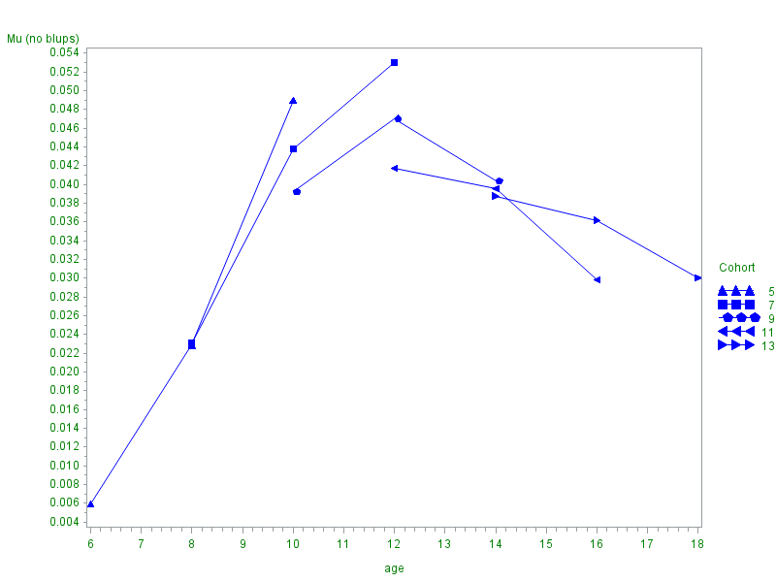

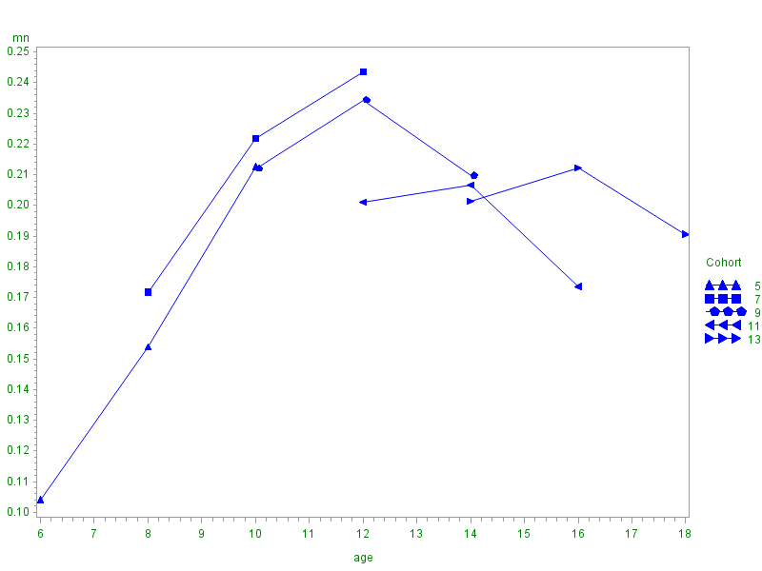

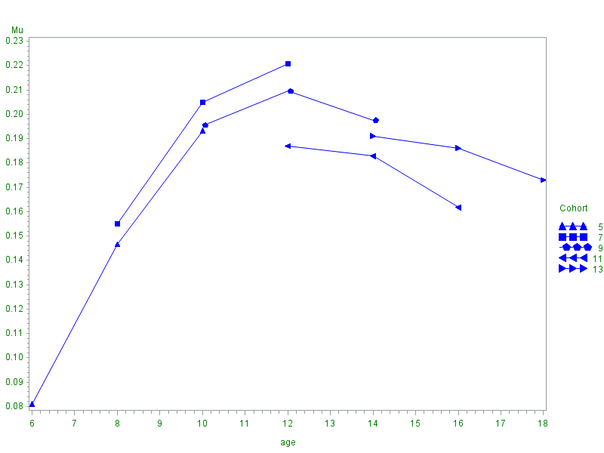

**Proc** **SGplot** data = merg_dat;

**PRED NO EBLUP**

series x=age y=pred / group =Cohort LineAttrs= (pattern=**1** color="black");

**Average outcome**

series x=age y=mn / group =Cohort LineAttrs= (pattern=**2** color="blue");

**EBLUP**

series x=age y=mn2/ group =Cohort LineAttrs= (pattern=**3** color="red");

**run**;

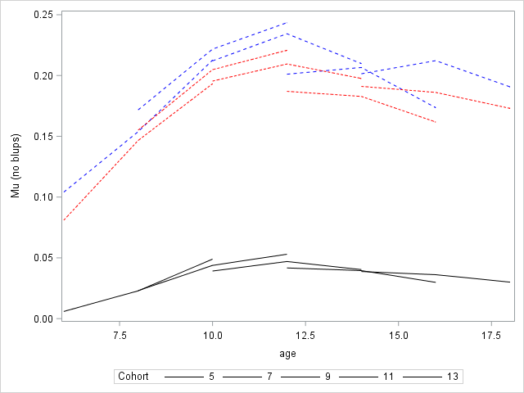

*Example - Schizophrenia

Data analyzed by Hedeker and Gibbons (1997). A randomized trial for schizophrenia. The trial contained

312 patients received drug therapy and 101 received placebo. The measurements were taken at weeks 0, 1, 3, 6,

but some subjects have missing data due to dropout. The outcome of interest is severity of illness (1 = normal, ... , 7 = extremely ill);

**data** schizo;

input ID Group week severity;

sqrtweek = week**(**0.5**);

r_severity = round(severity);

datalines;

1103 1 0 5.5

1103 1 1 3.0

1103 1 3 2.5

1103 1 6 4.0

……………………………

9316 0 0 5.5

9316 0 1 6.0

9316 0 3 6.5

9316 0 6 6.0

**run**;

**proc** **freq** data=schizo;

tables group*week;

**run**;

| **Table of Group by week** | | | | | |
| --- | --- | --- | --- | --- | --- |
| **Group** | **week** | | | | |
| **Frequency Percent Row Pct Col Pct** | **0** | **1** | **3** | **6** | **Total** |
| **0** | 101 6.11 25.00 24.46 | 101 6.11 25.00 24.46 | 101 6.11 25.00 24.46 | 101 6.11 25.00 24.46 | 404 24.46 |
| **1** | 312 18.89 25.00 75.54 | 312 18.89 25.00 75.54 | 312 18.89 25.00 75.54 | 312 18.89 25.00 75.54 | 1248 75.54 |
| **Total** | 413 25.00 | 413 25.00 | 413 25.00 | 413 25.00 | 1652 100.00 |

**proc** **univariate** data=schizo;

var severity;

histogram;

**run**;

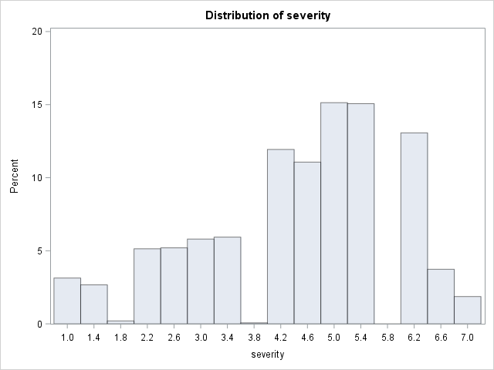

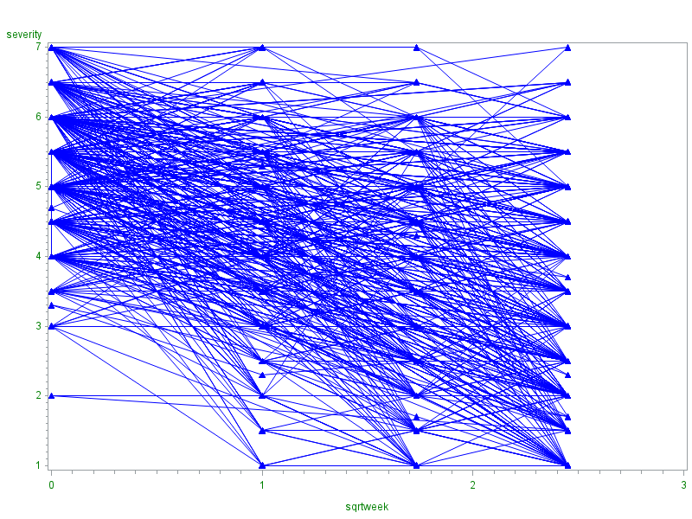

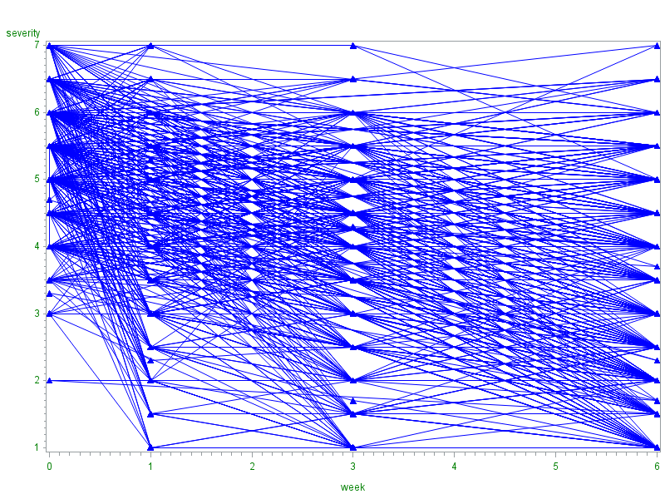

**proc** **glimmix** data=schizo method=RMPL;

class ID Group (ref="0");

model r_severity = Group sqrtweek Group*sqrtweek/solution link=cumlogit dist=multinomial;

random intercept/subject=ID type=UN G;

**run**;

| **Model Information** | |
| --- | --- |
| **Data Set** | WORK.SCHIZO |
| **Response Variable** | r_severity |
| **Response Distribution** | Multinomial (ordered) |
| **Link Function** | Cumulative Logit |
| **Variance Function** | Default |
| **Variance Matrix Blocked By** | ID |
| **Estimation Technique** | Residual MPL |
| **Degrees of Freedom Method** | Containment |

| **Class Level Information** | | |
| --- | --- | --- |
| **Class** | **Levels** | **Values** |
| **ID** | 413 | 1103 1104 1105 ………..9316 |
| **Group** | 2 | 1 0 |

|  |  |
| --- | --- |
| **Number of Observations Read** | 1652 |
| **Number of Observations Used** | 1500 |

| **Response Profile** | | |
| --- | --- | --- |
| **Ordered Value** | **r_severity** | **Total Frequency** |
| **1** | 1 | 47 |
| **2** | 2 | 120 |
| **3** | 3 | 166 |
| **4** | 4 | 268 |
| **5** | 5 | 394 |
| **6** | 6 | 421 |
| **7** | 7 | 84 |
| **The GLIMMIX procedure is modeling the probabilities of levels of r_severity having lower Ordered Values in the Response Profile table.** | | |

| **Dimensions** | |
| --- | --- |
| **G-side Cov. Parameters** | 1 |
| **Columns in X** | 11 |
| **Columns in Z per Subject** | 1 |
| **Subjects (Blocks in V)** | 413 |
| **Max Obs per Subject** | 4 |

| **Optimization Information** | |
| --- | --- |
| **Optimization Technique** | Dual Quasi-Newton |
| **Parameters in Optimization** | 1 |
| **Lower Boundaries** | 1 |
| **Upper Boundaries** | 0 |
| **Fixed Effects** | Profiled |
| **Starting From** | Data |

| **Iteration History** | | | | | |
| --- | --- | --- | --- | --- | --- |
| **Iteration** | **Restarts** | **Subiterations** | **Objective Function** | **Change** | **Max Gradient** |
| **0** | **0** | **4** | 28161.4378 | 2.00000000 | 0.00019 |
| **1** | **0** | **5** | 31754.375232 | 1.21312762 | 0.001151 |
| **2** | **0** | **3** | 32373.253267 | 0.08405759 | 0.000602 |
| **3** | **0** | **2** | 32383.501727 | 0.00164673 | 7.522E-8 |
| **4** | **0** | **2** | 32383.492634 | 0.00015664 | 1.132E-9 |
| **5** | **0** | **1** | 32383.476423 | 0.00000453 | 4.411E-6 |
| **6** | **0** | **0** | 32383.475503 | 0.00000045 | 5.13E-6 |
| **7** | **0** | **0** | 32383.475457 | 0.00000002 | 5.602E-6 |
| **8** | **0** | **0** | 32383.475454 | 0.00000000 | 5.633E-6 |

|  |
| --- |
| Convergence criterion (PCONV=1.11022E-8) satisfied. |

| **Fit Statistics** | |
| --- | --- |
| **-2 Res Log Pseudo-Likelihood** | 32383.48 |

| **Estimated G Matrix** | | |
| --- | --- | --- |
| **Effect** | **Row** | **Col1** |
| Intercept | **1** | 1.0920 |

| **Covariance Parameter Estimates** | | | |
| --- | --- | --- | --- |
| **Cov Parm** | **Subject** | **Estimate** | **Standard Error** |
| **UN(1,1)** | ID | 1.0920 | 0.1399 |

| **Solutions for Fixed Effects** | | | | | | | |
| --- | --- | --- | --- | --- | --- | --- | --- |
| **Effect** | **r_severity** | **Group** | **Estimate** | **Standard Error** | **DF** | **t Value** | **Pr > |t|** |
| **Intercept** | 1 |  | -5.3218 | 0.2523 | 411 | -21.09 | <.0001 |
| **Intercept** | 2 |  | -3.8528 | 0.2188 | 411 | -17.61 | <.0001 |
| **Intercept** | 3 |  | -2.8738 | 0.2090 | 411 | -13.75 | <.0001 |
| **Intercept** | 4 |  | -1.7987 | 0.2015 | 411 | -8.93 | <.0001 |
| **Intercept** | 5 |  | -0.4393 | 0.1951 | 411 | -2.25 | 0.0249 |
| **Intercept** | 6 |  | 1.9550 | 0.2127 | 411 | 9.19 | <.0001 |
| **Group** |  | 1 | -0.01599 | 0.2220 | 1080 | -0.07 | 0.9426 |
| **Group** |  | 0 | 0 | . | . | . | . |
| **sqrtweek** |  |  | 0.4862 | 0.1138 | 1080 | 4.27 | <.0001 |
| **sqrtweek*Group** |  | 1 | 0.8172 | 0.1299 | 1080 | 6.29 | <.0001 |
| **sqrtweek*Group** |  | 0 | 0 | . | . | . | . |

| **Type III Tests of Fixed Effects** | | | | |
| --- | --- | --- | --- | --- |
| **Effect** | **Num DF** | **Den DF** | **F Value** | **Pr > F** |
| **Group** | 1 | 1080 | 0.01 | 0.9426 |
| **sqrtweek** | 1 | 1080 | 176.53 | <.0001 |
| **sqrtweek*Group** | 1 | 1080 | 39.60 | <.0001 |